Bidirectional

🔁 What Is Bidirectional Network Traffic?
# Source: AI Source: Provided by: [Data Path: Persons Table -> ID Column: 1, Name_En Column: Motasem Essam] -> From: [ChatGPT] on [12/18/2025]
Bidirectional traffic refers to two-way communication between devices over a network — meaning both the sender and the receiver exchange data. It is the most common type of traffic in modern networks.

🧠 Simple Definition:
# Source: AI Source: Provided by: [Data Path: Persons Table -> ID Column: 1, Name_En Column: Motasem Essam] -> From: [ChatGPT] on [12/18/2025]
Bidirectional traffic is when data flows in both directions between two devices — like a conversation where both people speak and listen.

📡 Real-World Examples
# Source: AI Source: Provided by: [Data Path: Persons Table -> ID Column: 1, Name_En Column: Motasem Essam] -> From: [ChatGPT] on [12/18/2025]
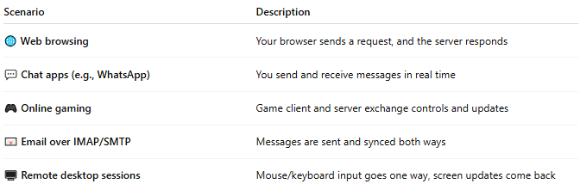
Scenario | Description
🌐 Web browsing | Your browser sends a request, and the server responds
💬 Chat apps (e.g., WhatsApp) | You send and receive messages in real time
🎮 Online gaming | Game client and server exchange controls and updates
📧 Email over IMAP/SMTP | Messages are sent and synced both ways
🖥️ Remote desktop sessions | Mouse/keyboard input goes one way, screen updates come back

🔄 Flow Behavior
# Source: AI Source: Provided by: [Data Path: Persons Table -> ID Column: 1, Name_En Column: Motasem Essam] -> From: [ChatGPT] on [12/18/2025]
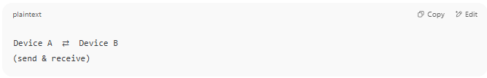
Device A ⇄ Device B
(send & receive)

Both parties:
- Initiate requests
- Respond to each other
- Maintain sessions

⚙️ Common Protocols for Bidirectional Traffic
# Source: AI Source: Provided by: [Data Path: Persons Table -> ID Column: 1, Name_En Column: Motasem Essam] -> From: [ChatGPT] on [12/18/2025]

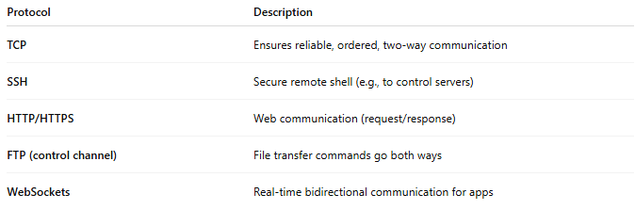
Protocol | Description
TCP | Ensures reliable, ordered, two-way communication
SSH | Secure remote shell (e.g., to control servers)
HTTP/HTTPS | Web communication (request/response)
FTP (control channel) | File transfer commands go both ways
WebSockets | Real-time bidirectional communication for apps

✅ Benefits of Bidirectional Traffic
# Source: AI Source: Provided by: [Data Path: Persons Table -> ID Column: 1, Name_En Column: Motasem Essam] -> From: [ChatGPT] on [12/18/2025]
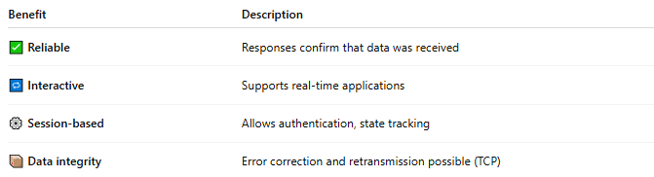
Benefit | Description
✅ Reliable | Responses confirm that data was received
🔁 Interactive | Supports real-time applications
⚙️ Session-based | Allows authentication, state tracking
📦 Data integrity | Error correction and retransmission possible (TCP)

⚠️ Limitations / Considerations
# Source: AI Source: Provided by: [Data Path: Persons Table -> ID Column: 1, Name_En Column: Motasem Essam] -> From: [ChatGPT] on [12/18/2025]
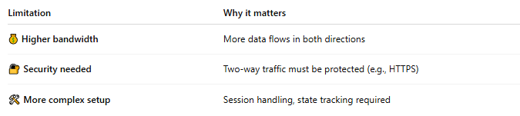
Limitation | Why it matters
💰 Higher bandwidth | More data flows in both directions
🔐 Security needed | Two-way traffic must be protected (e.g., HTTPS)
🛠 More complex setup | Session handling, state tracking required

🔁 Bidirectional vs. Unidirectional
# Source: AI Source: Provided by: [Data Path: Persons Table -> ID Column: 1, Name_En Column: Motasem Essam] -> From: [ChatGPT] on [12/18/2025]
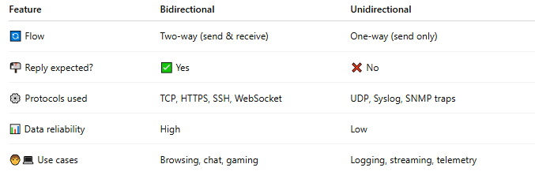
Feature | Bidirectional | Unidirectional
🔄 Flow | Two-way (send & receive) | One-way (send only)
📬 Reply expected? | ✅ Yes | ❌ No
⚙️ Protocols used | TCP, HTTPS, SSH, WebSocket | UDP, Syslog, SNMP traps
📊 Data reliability | High | Low
🧑‍💻 Use cases | Browsing, chat, gaming | Logging, streaming, telemetry

📌 Summary
# Source: AI Source: Provided by: [Data Path: Persons Table -> ID Column: 1, Name_En Column: Motasem Essam] -> From: [ChatGPT] on [12/18/2025]
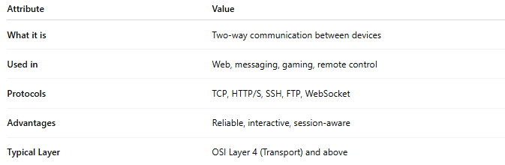
Attribute | Value
What it is | Two-way communication between devices
Used in | Web, messaging, gaming, remote control
Protocols | TCP, HTTP/S, SSH, FTP, WebSocket
Advantages | Reliable, interactive, session-aware
Typical Layer | OSI Layer 4 (Transport) and above

